  Coleman Primary School |  | Key Knowledge Organiser: Year 5- Autumn 1  Computing: WE ARE GAME DEVELOPERS  In this unit, pupils plan their own simple computer game. They design characters and backgrounds, and create a working prototype, which they develop further based on feedback they receive.
Key Vocabulary |  |  | Images:  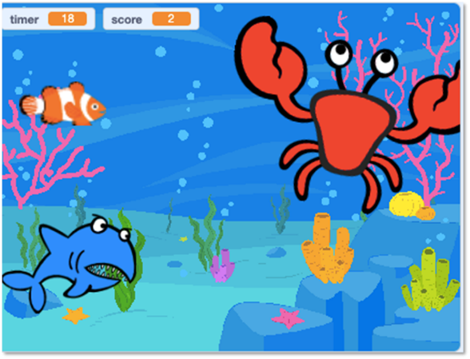
Algorithm | A sequence of precise instructions or steps (sometimes a set of rules) to achieve an objective
Background | Scenery and other unchanging elements in a game
Bug | An error or mistake in a program or algorithm, causing the computer or robot to behave in a manner that was not originally intended
Code | Instructions (or sometimes rules) that can be understood by a computer
Debug | Correct mistakes in a computer game or algorithm
Iterative development | A trial and improvement approach in which each successive version builds on the previous one by the fixing of mistakes or the adding of features
Logical reasoning | A systematic approach to solving problems or deducing information using a set of universally applicable and totally reliable rules
Program | An automated solution to a problem
Scratch | Simple, block-based programming language in which programs for characters are built by snapping together code blocks
Sprite | A graphical character in a program that can be given its own sequence of instructions

Key skills learnt prior to this unit | Key skills learnt in this unit
Year one  - understand algorithms as sequences of instructions and how algorithms are implemented as programs on digital devices  - create and debug simple programs  - use reasoning to predict the behaviour of simple programs.  Year two  - understand what algorithms are; how they are implemented as programs on digital devices and that programs execute by following precise and unambiguous instructions  - create and debug simple programs  - use logical reasoning to predict the behaviour of simple programs.  Year three  - design, write and debug programs  - use sequence in programs; work with various forms of output  - begin to use reasoning to explain how some simple algorithms work and to detect errors in programs  - begin to understand computer networks including the internet and how they can provide multiple services, such as the World Wide Web  Year four  - design, write and debug programs that accomplish specific goals  - use sequence and repetition in programs; work with inputs and outputs  - use reasoning to explain how some simple algorithms work and to detect and correct errors in programs  - begin to understand computer networks including the internet and how they can provide multiple services, such as the World Wide Web | ● create original artwork and sound for a game  ● design and create a computer program for a computer game, which uses sequence, selection, repetition and variables  ● detect and correct errors in their games  ● use iterative development techniques

