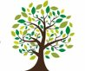  Coleman Primary School |  | Key Knowledge Organiser: Science – Material World Year 5 - Autumn 1  Properties and Changes of Materials  - Grouping materials and their everyday uses  - Thermal Conductors  - Electrical Conductors
Key Vocabulary |  |  | 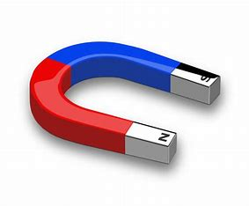  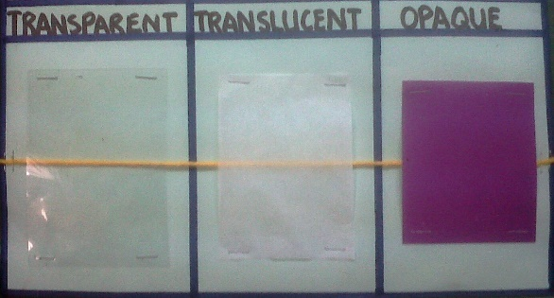  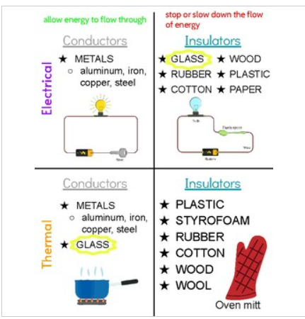
Material | What something is made from, e.g. wood, plastic, metal
Hardness | Solid, stiff and difficult to bend or break
Rigid | hard and fixed; not flexible
Flexible | Easily bends without breaking
Brittle | Hard but easily broken
Property | A quality that something has, e.g., magnetic, hard, soft
Transparent | Light can pass fully through
Translucent | Some light can pass through
Opaque | No light can pass through
Magnetic | Attracted to magnets
Insulator | A material that does not let heat or electricity travel through it
Conductor | A material that lets heat or electricity travel through it
Key Knowledge  - I know how to compare and group materials based on hardness, transparency and magnetism.  - I know that thermal conductors allow heat to pass through and thermal insulators make it harder for heat to pass through materials.  - I know that electrical conductors allow electricity to pass through and electrical insulators make it harder for electricity to pass through materials.  - I know that different materials are suitable for different jobs because of their properties, e.g. copper is good for electrical wires because it conducts electricity well. |  |  | Working Scientifically:  - Plan different types of scientific enquiries to answer questions  - Identify scientific evidence that has been used to support or refute ideas or arguments  - Report and present findings from enquiries, including conclusions, causal relationships and explanations of and a degree of trust in results, in oral and written forms such as displays and other presentations. | In Year 4, you learned:  - What solids, liquids and gases are  - How materials can change state through melting, freezing and evaporation

