 Coleman Primary School | Key Knowledge Organiser: Year 5- Autumn 1  DT – Structures - Bridges
Key Vocabulary  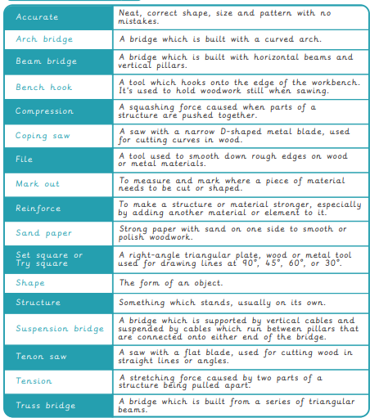 |  | Images:  

