 Coleman Primary School | Key Knowledge Organiser: Year 5- Autumn 1  Music - Pulse
Key Vocabulary  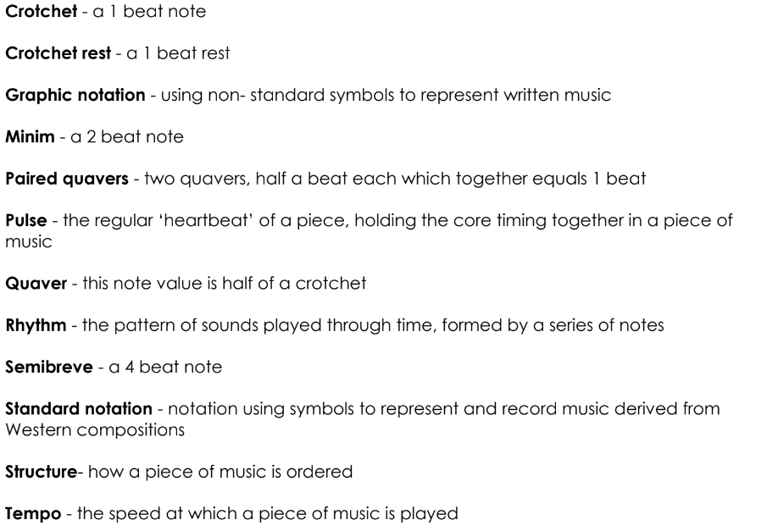 |  | Images:  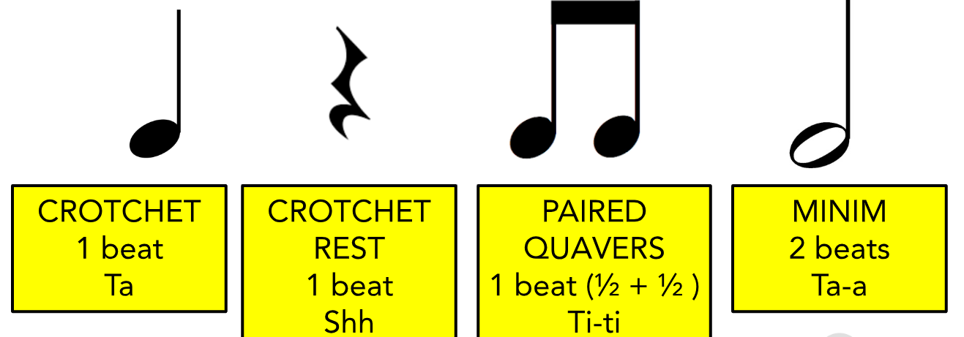  Key Skills  Sing / Play confidently, identifying and maintaining a strong sense of pulse.  • Create simple rhythmic pieces which demonstrate understanding of rhythm using  graphic and standard notation.  • Read simple rhythms using paired quavers, crotchets, crotchet rests, minims and  semibreves.  • Maintain an independent part in a group with accuracy when playing.  • Comment on own and other people’s performances using Yr 5 vocabulary learnt

