  Coleman Primary School |  | Key Knowledge Organiser: Year 5- Autumn 1.  PSHE – Beginning and Belonging  Key Questions:  What are my responsibilities for helping others in school feel happy and safe? • How can I take responsibility for building relationships in my school and how does this benefit us all? • How might different people feel when starting something new and how can I help? • How do we help people feel welcome and valued in and out of school? • What helps me to be resilient in a range of new situations? • Are there more ways I can get help now and how do I seek support?
Key Vocabulary |  |  | Images:  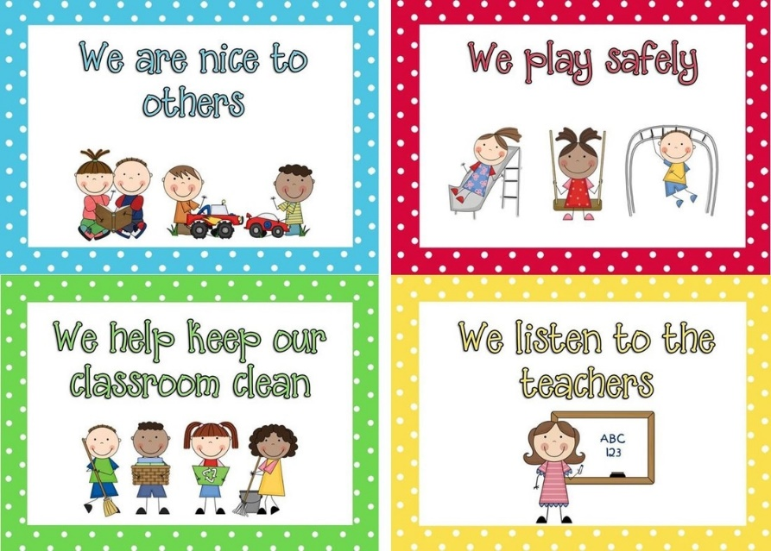
Responsibility | the state or fact of being accountable
Resilience | he capacity to recover quickly from difficulties
Belonging | an affinity for a place or situation
Emotions | a strong feeling deriving from one's circumstances, mood, or relationships with others
Metacognition | awareness and understanding of one's own thought processes
Friendship | a relationship between friends
Empathy | the ability to understand and share the feelings of another
 |  |  | PSHE skills learned prior to this unit:  - Ground rules / class charters  - Responsibilities  - Belonging  - New situations  - Meeting new people  - Resilience  - Managing feelings  - Asking for help  - Networks of support | PSHE skills learned during this unit:  - Ground Rules / class charters  - Responsibilities  - Belonging  - New experiences  - Resilience  - Managing emotions  - Networks of support  - Online sources of support

