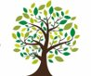 Coleman Primary School |  | Key Knowledge Organiser: Year 5- Autumn 2.  History – Ancient Egyptians  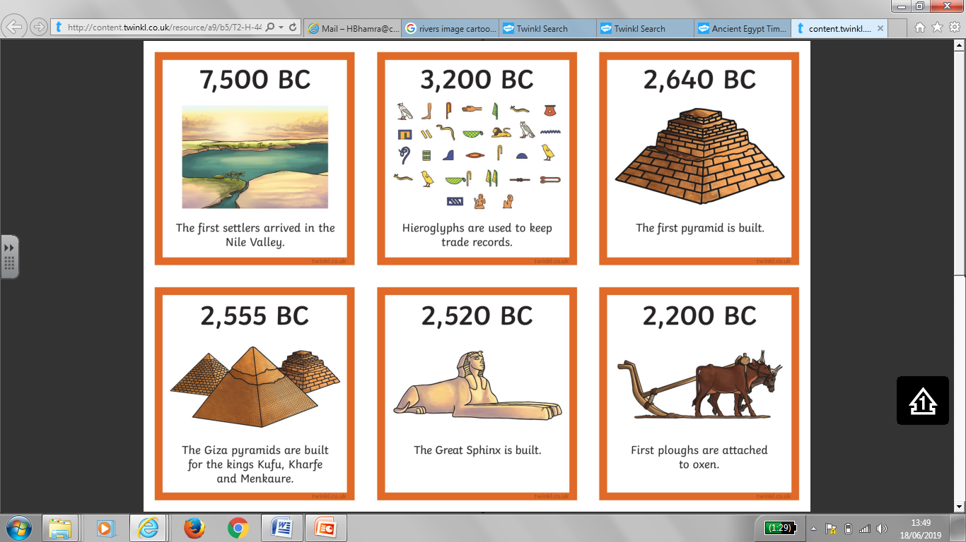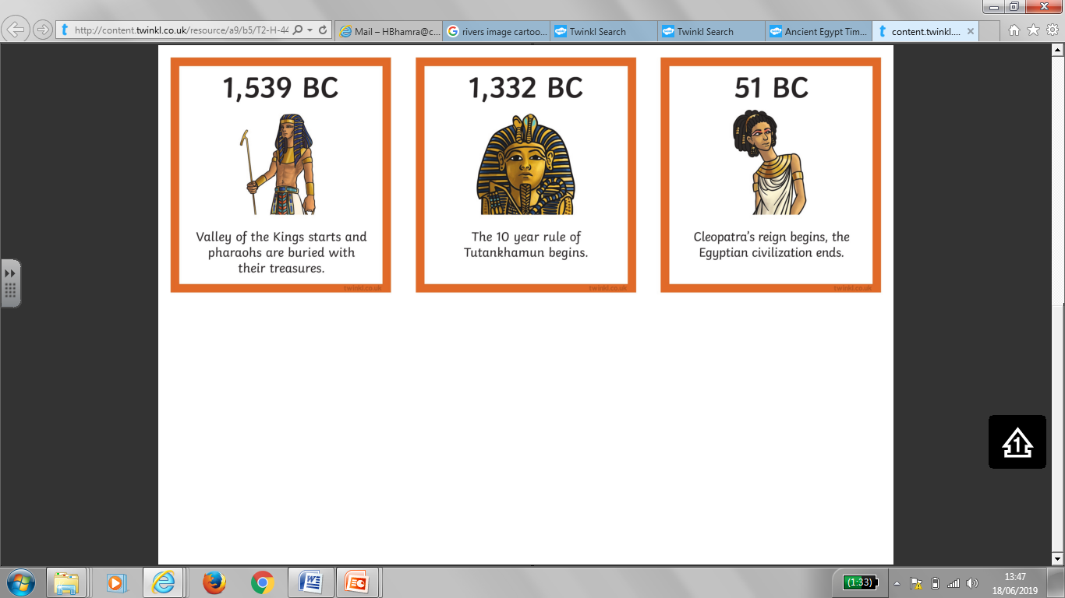
Key Vocabulary |  |  | 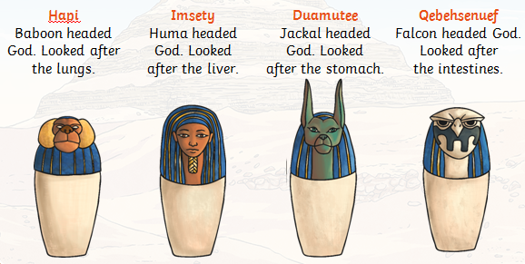  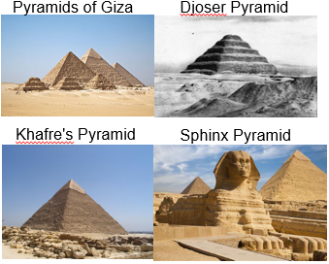  Images:
Pyramid | A triangular tomb
Papyrus | A plant used to make paper
Irrigation systems | A way to transport water
Nile River | The world’s longest river
Delta | Landform at the mouth of a river
Silt | Very fine, sandy material
Sarcophagus | A stone coffin
Pharaoh | What an Egyptian ruler is called
King Tutankhamun | An important young Pharaoh
Hatshepsut | First female Pharaoh
Sphinx | Has the body of a lion and the head of a human
Mummification | A process of preserving a dead body
Hieroglyphics | A picture used to write something
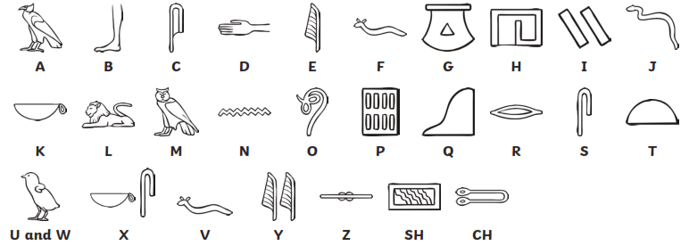 |  |  | Prior to year 5 you: | In year 5 you will :  *To know that the Ancient Egyptian era lasted from 7,500 BC to 51 BC.  *To know Egypt is in northern Africa.  *To know that the river Nile was important for transport, trade and agriculture.  *To know pyramids were built in northern Egypt near Giza.  *To know pyramids were built as tombs for pharaohs.  *To know some of the items that were put into the tombs e.g. gold, jewellery, weapons, slaves, wives, cats, food etc because the needed it for the afterlife  * To know the process of mummification which includes; removing the brain and organs and placing them in canopic jars, stuffing the body and wrapping the body.  *To know the Egyptians wrote using hieroglyphic symbols and that they were read from right to left.

