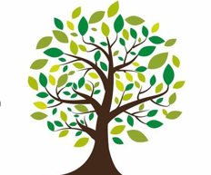  Coleman Primary School |  | Key Knowledge Organiser: Year 6- Summer 2  PSHCE: Relationships education  - In this unit the children will learn about stable, caring relationships, which may be of different types, are at the heart of happy families, and are important for children’s security as they grow up.  - That marriage represents a formal and legally recognised commitment of two people to each other which is intended to be lifelong.  - Key facts about puberty and the changing adolescent body, particularly from age 9 through to age 11, including physical and emotional changes.  - Where babies come from and to understand the process of human reproduction, from conception to birth.
Key Vocabulary |  |  | Images:  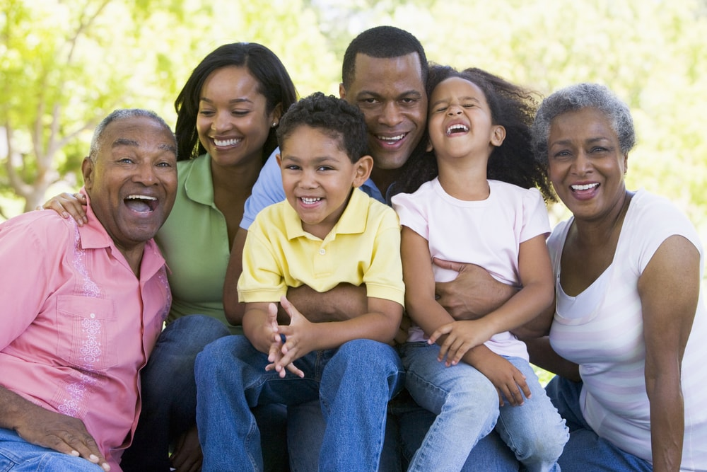
puberty | the time when a boy or girl's body begins to develop and change as they become an adult.
changes | Physical and emotional differences which occur during puberty
Breasts | Glands on a female body that produce milk for offspring
Pubic hair | Hair which develops around the genitals and other bodily areas during puberty
Hips | These become wider in females during puberty to prepare for child birth
Genitals | Reproductive organs in males and females
Muscular development | An increase in testosterone production in boys results in an increase in muscle mass. In girls estrogen production causes body fat deposition, breast development and widening of the hips. |  | Knowledge:  *To know the main changes that occur during puberty.  *To know some reasons that changes occur during puberty.  *To know some similarities and differences between how girls and boys experience puberty.  *To know scientific vocabulary related to puberty and changes.  *To know some of the emotional changes which occur in puberty.  *To know where to get help and advice if needed.  *To know that people differ in terms of sexual orientation and who they love.  *To know what makes a loving relationship.  *To know the stages in the process of human reproduction, from conception to birth | Learned prior to this unit:  - Puberty  - Physical and emotional change  - Menstruation  - Developing body image  - Changing hygiene routines  - Viruses and bacteria  Learned during this unit:  - Human reproduction  - Changing emotions and  relationships  - Responsibility for others  - Love and care  - Marriage & civil  partnership  • Families of different types
menstruation | Another word for a period. This is the 2-7 days that a female has her menstrual flow, which is when blood and tissue leave the body through the vagina.
Penis | A male organ in mammals through which urine and sperm leave the body
vagina | A canal that leads from the uterus to the outside of the female body
Sperm | Male reproductive cells. If the sperm meets with the egg of the female, it can grow into a new organism.
egg | Female reproductive cell created in the female ovaries. When fertilised by a sperm cell a new organism is produced.
fertilise | The process when a male sperm cell combines with the female egg cell.
Womb | The part inside the mother where a baby grows before it is born
relationship | A strong feeling of affection and concern for another person arising from kinship or close friendship.
emotions | During puberty a young persons’ feelings may become stronger and more intense. They can experience frequent mood changes or experience feelings that they have never had before
Uterus  reproduction | This is where the fetus grows. It is a hollow, pear shaped organ with a muscular wall  The process by which all living things produce offspring

