  Coleman Primary School |  | Key Knowledge Organiser: Year 6- Summer 2  Geography: Who are Britain’s National Parks for?  In this unit, pupils will learn about the 15 National Parks in Great Britain, what they are and why they are important in conserving areas of outstanding natural beauty and the cultural traditions of the area in which they are situated. They will study features of National Parks on a national level before comparing them to a National Park in the US which they have studied in lower KS2.
Key Vocabulary |  |  | Images:  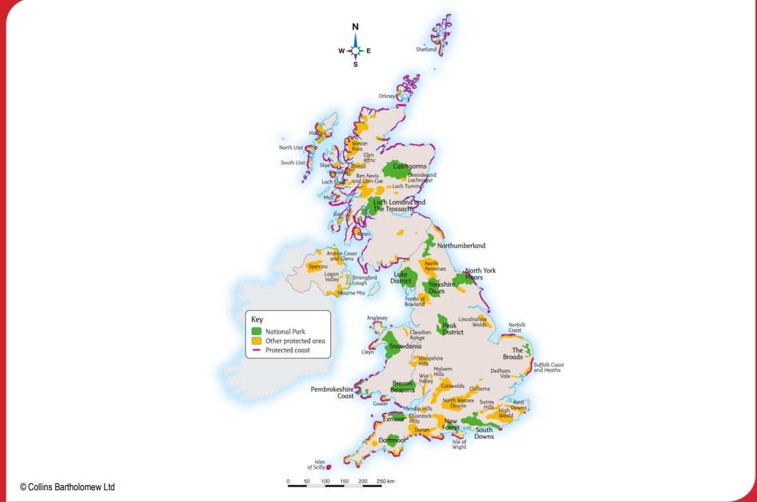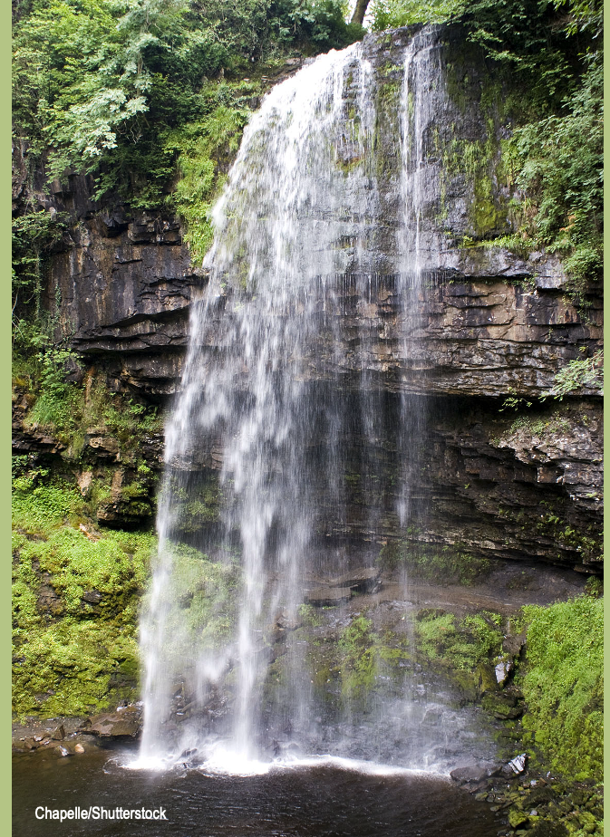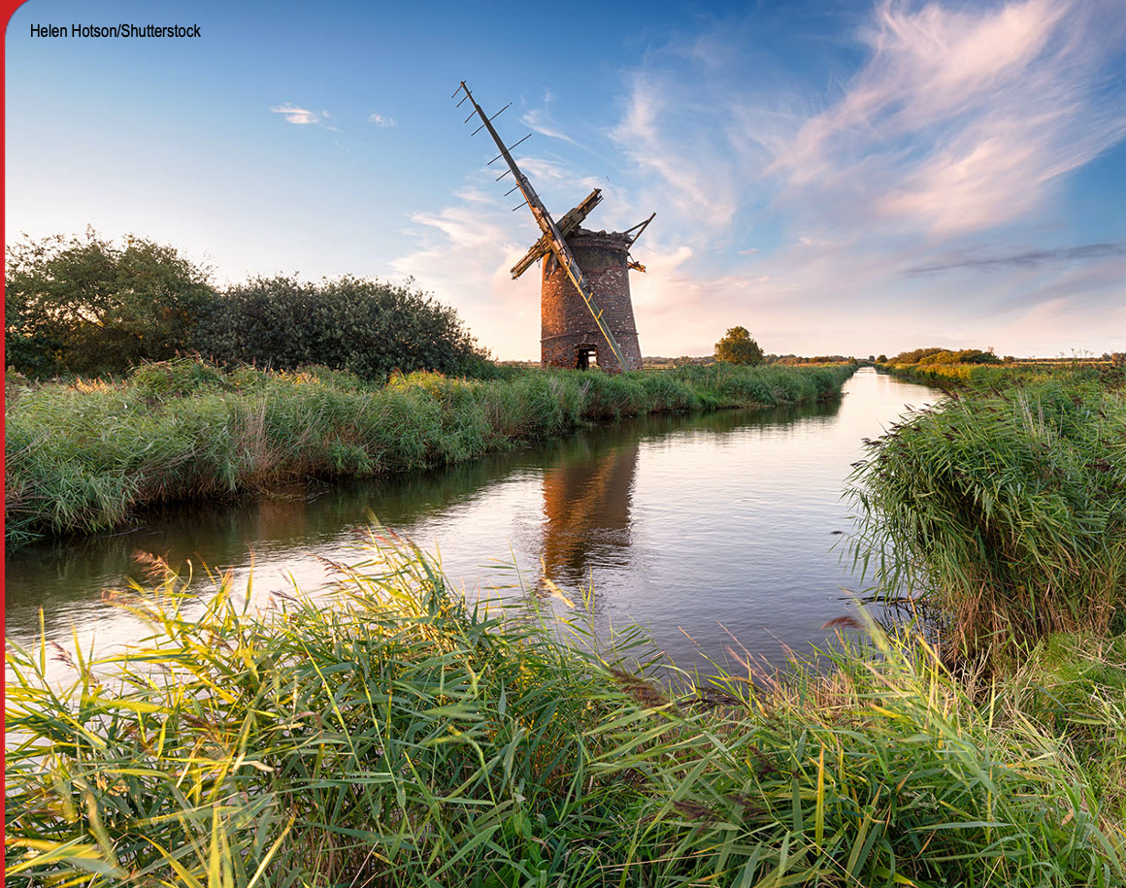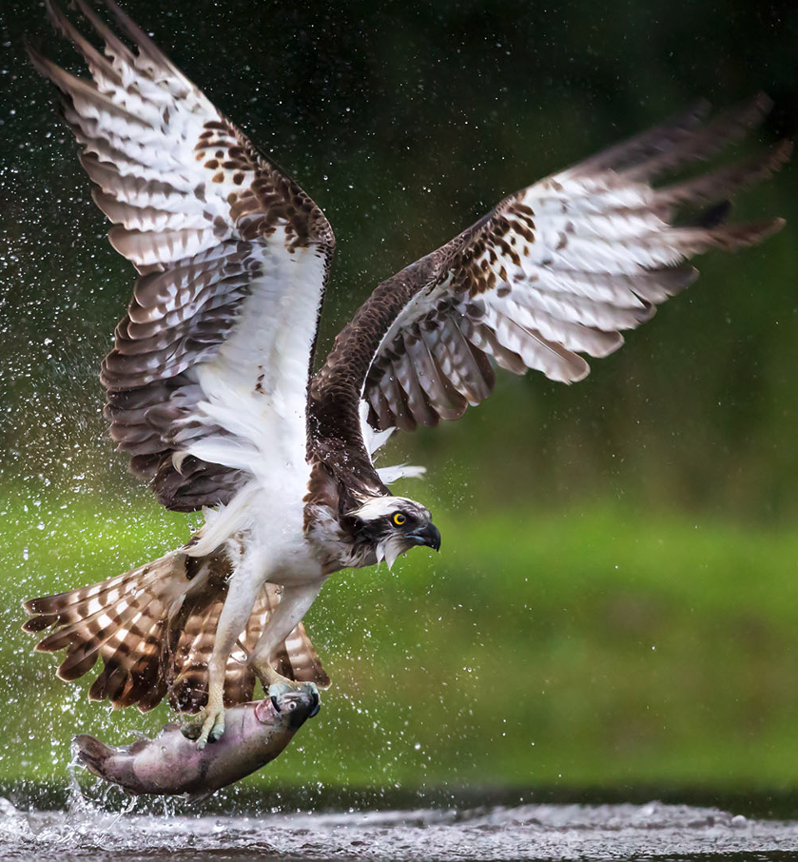  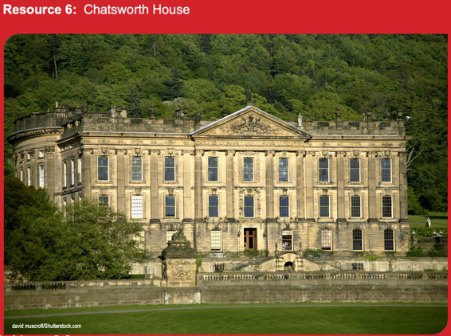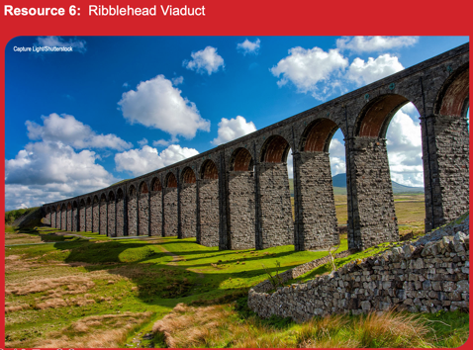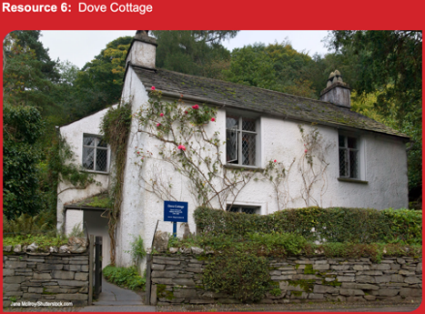
National Park | A national park is a natural park containing natural or developed land in use for conservation purposes, created and protected by national governments.
United Kingdom | The United Kingdom is made up of England, Northern Ireland, Scotland and Wales. It is an island nation north western Europe.
Conservation/conserve | Nature conservation is focused on protecting species, landscapes, geographical features or cultural traditions in an area.
Protected areas | Locations which receive protection because of their ecological or cultural values.
Region | Regions of England are the highest tier of sub-national division in England. There are 9 regions of the UK: (North East, North West, Yorkshire and the Humber, East Midlands, West Midlands, East of England, London, South East and South West)
landscape | A landscape is part of the earth’s surface that can be viewed at one time from one place.
landscape |  |  | Knowledge:  - L.I. To know that National Parks are important in developing develop physical, mental and spiritual well-being  - L.I. To know that National Parks are important in preserving cultural heritage  To know how National Parks encourage visitors to enjoy and learn about what makes them special.  - To know that the Southwest of England contains 25% of the protected land in the UK  - To know how Exmoor and Dartmoor National Parks compare with the Everglades National Park in Florida | Skills learned prior to this unit:  - Describe and understand key aspects of :  Physical geography including coasts.  - Describe and understand geographical similarities and differences through the study of human and physical geography  - Locate the main countries in a studied area. Locate and name principal cities, concentrating on their environmental regions, key physical and human characteristics, countries and other major cities.  Skills learned this unit:  - Use maps, atlases, globes and digital/computer mapping to locate areas and describe features studied  - Use the eight points of a compass  - Use four and six-figure grid references, symbols and key (including the use of Ordnance Survey maps) to build their knowledge of the United Kingdom and the wider world.  - Compare and contrast the proportion of protected land here with other regions of the UK
Cultural tradition | Values, practices and traditions of people in an area of society. They make up the identity of peoples and places and include their beliefs and values.
Heritage | This includes natural and built landscapes, objects and culture (music, art, monuments etc) as well as beliefs.
environment | The surroundings in which a person or animal lives.
Economic activity | Ways in which an area creates goods or services to create jobs and industry.
Land use | The human use of land in an area

