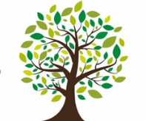  Coleman Primary School |  | Key Knowledge Organiser: Year 6- Summer 2.  Athletics: Decathlon. To develop knowledge of preparing for, participating in, and  recovering from a training session to improve athletic fitness. To develop personal performance as an athlete and an official in run,  jump and throw events. To compete, measure, record and compare performances in running,  jumping and throwing.
Key Vocabulary |  |  | 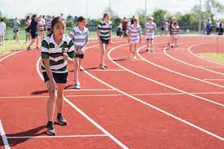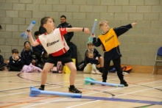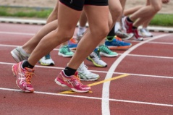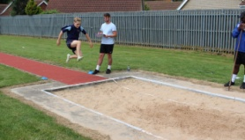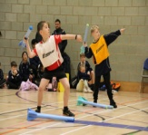
Decathlon  Refine and develop  Technique  Target  Monitor progress  Performance  Interval training | An event which includes 10 different event, including running, jumping and throwing  To improve and perfect technique in a sports event  Skill and ability in sports which is developed through practice  A performance goal to aim for through practice and training.  Watching and recording your performance to try and improve it.  The way participation in sport is measured.  Alternating short bursts of intense exercise with longer periods of less intense exercise
 |  |  | Knowledge:  *To know how to refine and develop a variety of running, jumping and throwing techniques.  *To know how to set  targets and monitor progress  *To know how to prepare for and recover from athletic performance; *To know how to understand the limits of own performance;  *To know how to apply rules of athletic events; use strategic thinking to improve performance;  *To know how to evaluate own and others’ performance. | Athletics Skills Progression:  Skills learned prior to this unit:  - I am starting to improve and sustain different running  techniques at different speeds in a variety of  athletic events.  - I am starting to show accuracy and technique in a range of throwing and jumping actions.  - I am beginning to identify and explain what makes a good athletic performance.  Skills learned in this unit:  - I can improve and sustain different running technique at different speeds in a variety of athletic events.  - I can demonstrate accuracy and technique in a range of throwing and jumping actions.  - I can identify and explain what makes a good athletic performance.  - I can explain how to improve technique in a variety of events
Main Muscle groups in athletics
Gastrocnemius - The chief muscle of the calf of the leg, which flexes the knee and foot.
Quadriceps - The large muscle at the front of the thigh which acts to extend the leg.
Groin – the area between the abdomen and the upper thigh on either side of the body.
Latissimus dorsi - a pair of large, roughly triangular muscles covering the lower part of the back
Triceps - the large muscle at the back of the upper arm.
Deltoid - A large triangular muscle that covers the shoulder joint and serves to raise the arm laterally
- Gluteus maximus - any of three muscles in each buttock which move the thigh, the largest of which is the gluteus maximus.

