Coleman Primary School |  | Key Knowledge Organiser: Year 6- Summer 2  French Unit 6: Performance time/Transition/Language Puzzle  In this unit, children will focus on the transition to year 7. They will have the opportunity to write a little bit about themselves, their families and their likes/dislikes. They will then complete a range of sketches where they order food - they will also have the chance to perform these.
Key Vocabulary |  |  | 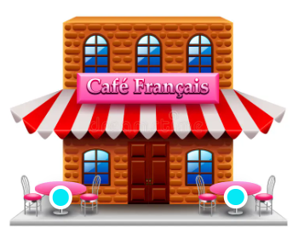  Images:  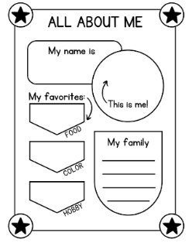
Bonjour | Hello. Good morning.
S’il vous plait | Please
Je voudrais | I would like
Bon appetit | Enjoy your meal
Fruit | Fruit
Legume | Vegetables
Une brindille | A twig
Feuilles | Leaf |  | Learning Objectives:  - To know how to write out a café sketch  - To know how to perform a café sketch.  - To know the names of some fruit and vegetables.  - To know the names of some nouns associated with nature and the classroom.  - To know what is meant by a scavenger hunt.  - To know how to solve puzzles using language skills. | French skills learned this unit:  - Speak confidently (words, phrases, sentences).  - Recall and use previously learnt language.  - Listen attentively.  - Join in with a game to aid memorisation.  - Take risks and learn from mistakes.  - Make educated guesses about meaning, using context.  - Practise new language with a friend.  - Use a bilingual dictionary to check spellings/new words.  - Make links with English and home languages.
Caillou | Pebble
Petals des fleurs | Flower petals
Un arbre | Tree
Un insecte | Insect
Un livre | book
plumier | Pencil case

