
Coleman Primary School Accessibility Plan.

Written Spring Term 2025
Review date: Spring Term 2027

Introduction

The SEN and Disability Act 2001 extended the Disability Discrimination Act 1995 (DDA) to cover education. Since September 2002, the Governing Body has had three key duties towards disabled pupils, under Part 4 of the DDA:
• not to treat disabled pupils less favourably for a reason related to their disability.
• to make reasonable adjustments for disabled pupils, so that they are not at a substantial disadvantage.
• to plan to increase access to education for disabled pupils.

The Governing Body of our school has set out these proposals in this plan to increase access to education for disabled pupils in the three areas required by the planning duties in the DDA:
• Increasing the extent to which disabled pupils can participate in the school curriculum.
• Improving the environment of the school to increase the extent to which disabled pupils can take advantage of education and associated services.
• Improving the delivery to disabled pupils of information which is provided in writing for pupils who are not disabled.

It is a requirement that our school’s accessibility plan is resourced, implemented, reviewed and revised as necessary and reported on annually.
Attached is a set of action plans showing how the school will address the priorities identified in the plan.

Discrimination
‘A responsible body’ discriminates against a disabled person if.
• For reasons which relate to his / her disability, it treats them less favourably than it treats or would treat others to whom the reason does not or would not apply, and
• It cannot show that the treatment in question is justified.
In line with the Disability and Discrimination Act (2001) School Practice, provision is guided by the Disability and Discrimination Code of Practice for Schools.
Visions and Values
Coleman Primary School aims to uphold a positive, non-discriminatory approach to disability, as part of its commitment to equal opportunities to primary education and will focus on removing barriers in every area of the life of the school.
Admissions
Coleman Primary School follow LA admissions procedures.
We will not discriminate against any child with a disability and will take all reasonable steps to provide effective educational provision and appropriate modification to the building where necessary. (see admission policy)
Pupil Data
At present we have 2 pupils who are included in the DDA definition of Disability and a further 7 pupils who have significant Physical or Sensory Needs as defined by the SEND Code of Practice (2014)
We consult with local nurseries to gain advance information of pupils with a disability or Physical/Sensory Need who may also be disabled and through parents who apply through admissions to the school.
Further information regarding pupils who have disability as a protected characteristic, and their participation in the life of the school can be found in their individual TEAMs folders.
Exclusions
LA exclusion procedures are followed to ensure that no disabled child is discriminated against by exclusion whether fixed term or permanent. Further information can be found in the Positive Behaviour Policy and the Exclusions Policy.
Curriculum and Life of the School
At Coleman Primary School we ensure that disabled pupils are not placed at a substantial disadvantage in comparison to pupils who are not disabled in accessing the curriculum, daily routines, extracurricular activities and the school environment.
The school recognises its duty to take reasonable steps or adjustments for all disabled pupils, and the school will therefore anticipate needs and adaptations to their broader school life.
The school recognises its duty to consider the broad range of needs and requirements of all pupils, current and future, and accordingly to plan and make changes to policies, procedures and practices, to ensure that disabled pupils will not be placed at a disadvantage.
In making reasonable adjustments and in drawing up accessibility plans to improve access over time, the school will take into account the LA’s accessibility strategies, the school’s own resources, the health and safety of all pupils, the practicalities of making adjustments and the need to maintain standards for all pupils.
The school will take proactive steps to promote disability equality for pupils, employees and service users.
Coleman Primary School endeavours to make the curriculum more accessible by following the good practice detailed in:
• Admissions Policy
• Equal Opportunities Policy
• Special Educational Needs Policy
• Teaching and Learning Policy
• Race Equality Policy
• School Improvement Plan
Complaints Procedure
If there are any complaints relating to provision for disabled children, these will be dealt with in the first instance by the Headteacher. The Chair of Governors and/or LA (Children and Young People’s Services) may be involved at this stage.
Monitoring
The governors will monitor this policy on a regular basis to ensure no pupils are placed at a substantial disadvantage or treated less favourably.
They will monitor the success of the policy and the accessibility plan by the low number of parental concerns raised.
Review
As a working document this document will be subject to continuous updating when necessary and will be reviewed every two years by the governing body.

IDENTIFYING BARRIERS TO ACCESS: A CHECKLIST
This list should help to identify barriers to access that exist in schools. The list is not exhaustive. It is designed to encourage a flexible approach to the further questioning of the accessibility of our school.
SECTION 1: How does our school deliver the curriculum?
Question | Yes | No
Do we ensure that teachers and teaching assistants have the necessary training to teach and support disabled pupils? | x
Are our classrooms optimally organized for disabled pupils? | x
Do lessons provide opportunities for all pupils to achieve? | x
Are lessons responsive to pupil diversity? | x
Do lessons involve work to be done by individuals, pairs, groups and the whole class? | x
Are all pupils encouraged to take part in music, drama and physical activities? | x
Do staff recognise and allow for the mental effort expended by some disabled pupils, for example using lip reading? | x
Do staff recognise and allow for the additional time required by some disabled pupils to use equipment in practical work? | x
Do staff provide alternative ways of giving access to experience or | x
Do we provide access to computer technology appropriate for students with disabilities? | x
Are school visits, including overseas visits, made accessible to all pupils irrespective of attainment or impairment? | x
Are there high expectations of all pupils? | x
Do staff seek to remove all barriers to learning and participation? | x

SECTION 2: Is our school designed to meet the needs of all pupils?
Question | Yes | No
Does the size and layout of areas – including all academic, sporting, play, social facilities; classrooms, the assembly hall, canteen, library, gymnasium and outdoor sporting facilities, playgrounds and common rooms – allow access for all pupils? | x
Can pupils who use wheelchairs move around the school without experiencing barriers to access such as those caused by doorways, steps and stairs, toilet facilities and showers? | x
Are pathways of travel around the school site and parking arrangements safe, routes logical and well signed? | x
Are emergency and evacuation systems set up to inform ALL pupils, including pupils with special educational needs and disabilities, including alarms with both visual and auditory components? (PEEPS evacuation risk assessment must be completed for any disabled individual) | x
Are non-visual guides used, to assist people to use buildings including lifts with tactile buttons? | x
Could any of the décor or signage be considered to be confusing or disorientating for disabled pupils with visual impairment, autism or epilepsy? |  | x
Are areas to which pupils should have access well lit? | x
Are steps made to reduce background noise for hearing impaired pupils such as considering a room’s acoustics and noisy equipment? | x
Is furniture and equipment selected, adjusted and located appropriately? | x

SECTION 3: How does our school deliver materials in other formats?
Question | Yes | No
Do we provide information in simple language, symbols, large print, on audiotape or in Braille for pupils and prospective pupils who may have difficulty with standard forms of printed information? | x
Do we ensure that information is presented to groups in a way which is user friendly for people with disabilities e.g. by reading aloud overhead projections and describing diagrams? | x
Do we have the facilities such as ICT to produce written information in different formats? | x
Do we ensure that staff are familiar with technology and practices developed to assist people with disabilities? | x

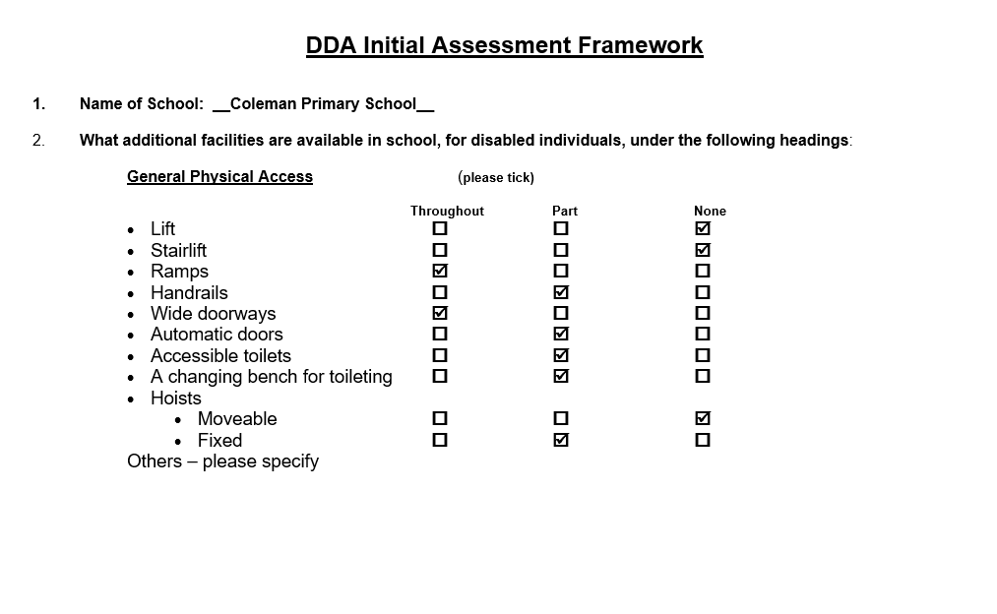
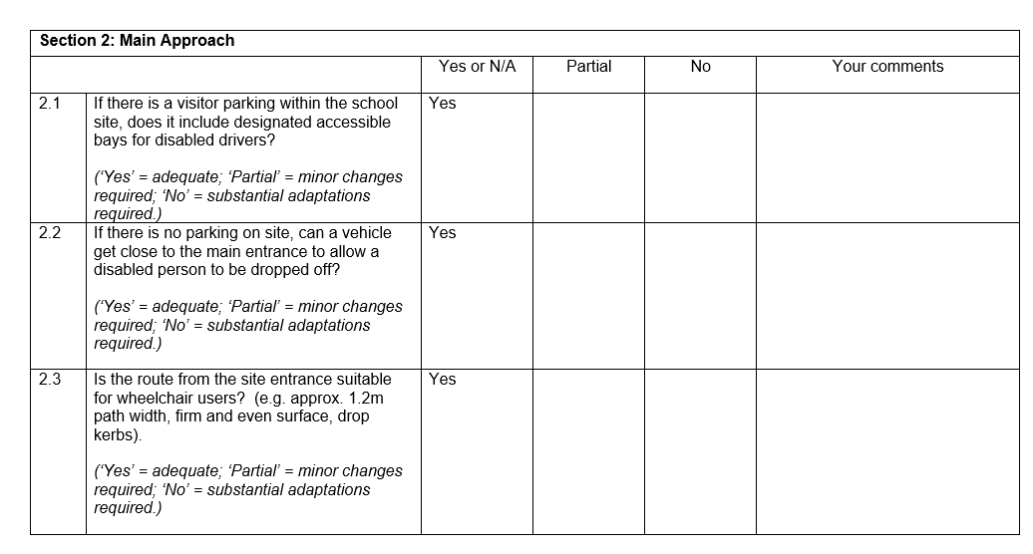
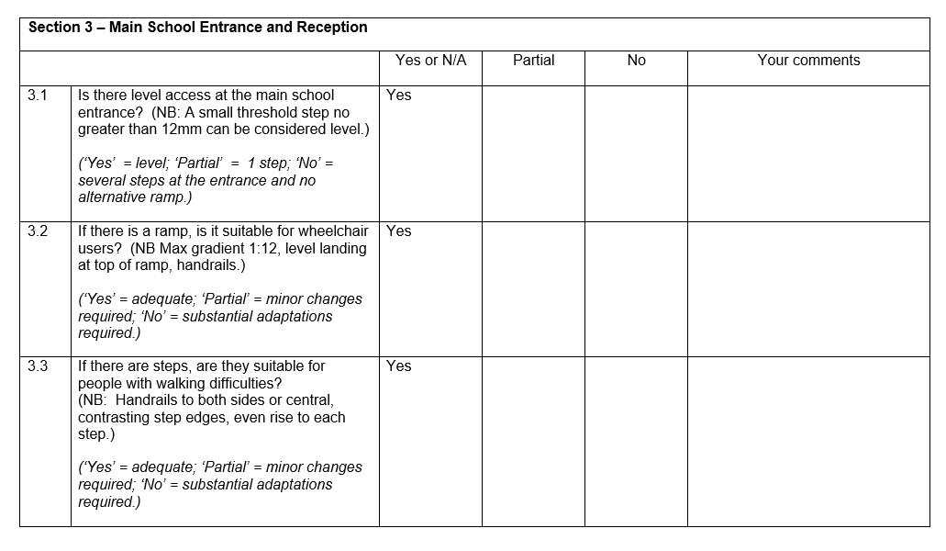
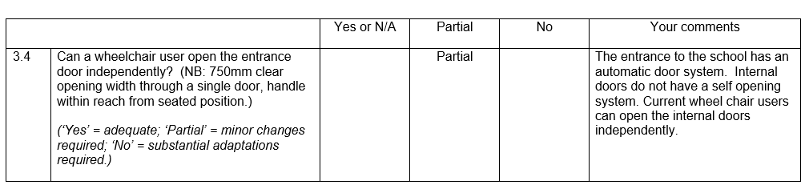
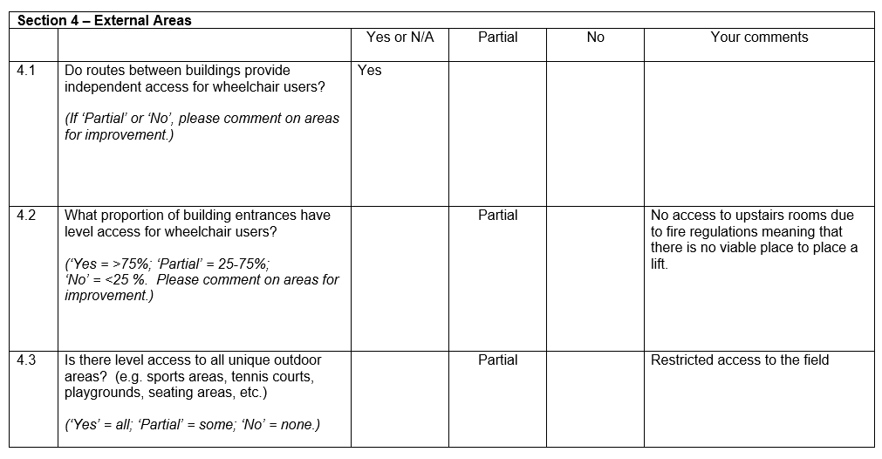
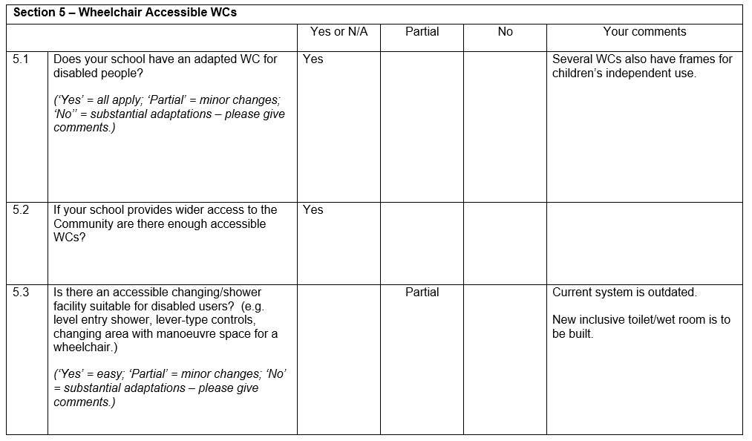
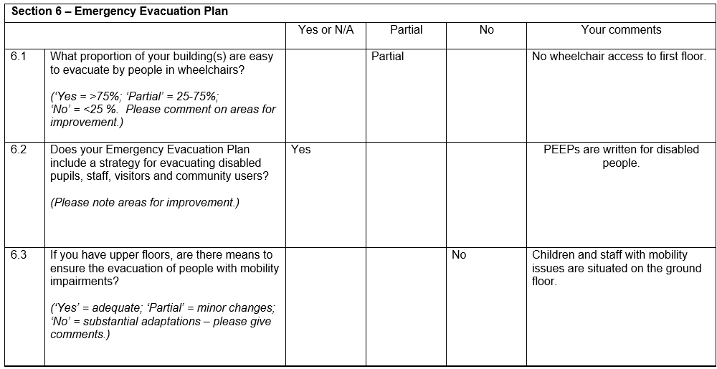
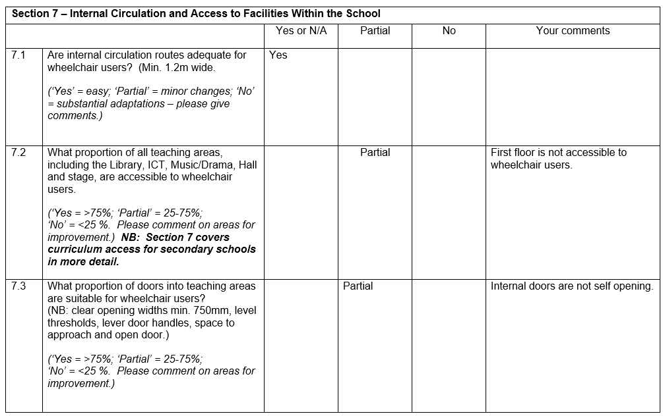
Action plan
This action plan sets out the aims of the accessibility plan in accordance with the Equality Act 2010.

Aim | Current good practice | Objectives | Date to complete actions by | Outcomes
Increase access to the curriculum for pupils with a disability | - Our school offers an adapted curriculum for all pupils where appropriate  - Pupils who require support to access the curriculum have resources that are tailored to meet their specific needs.  - Curriculum progress is tracked for all pupils, including those with a disability  - If a learning plan is in place, targets are set termly and are reviewed with parents and pupils.  - The curriculum is now regularly reviewed to make sure it meets the needs of all pupils  - Children access all areas of the curriculum such as PE, trips etc.  - School has advice from professionals to support with access to the curriculum e.g., hearing and vision support teams, occupational health, physio. | Short term:  Curriculum resources will include examples of people with disabilities  Medium term  Providing assistive technology to support the child to support access to the curriculum | Ongoing | All children have access to an adapted curriculum that is bespoke to their needs.
Improve and maintain access to the physical environment | Coleman is a multi-level school with access ramps to enter and exit the building. We cannot have a lift due to fire regulations and lack of a suitable site (Feb 2025)  Year group classes are moved to ground floor accommodation so that children with disabilities are able to access a suitable classroom that supports their safe movement around the school.  The environment is adapted to the needs of pupils as required. This includes:  - Ramps  - Corridor width  - Disabled parking bays  - Disabled toilets and changing facilities  - Access to a habilitation specialist | Medium term:  Creation of an additional inclusive bathroom and washroom area on the ground floor. | Ongoing | Using specialist services advice (OT, Physio, Vision Support, Hearing Support) to make informed choices about the school’s physical environment and how people use it.
Improve the delivery of information to pupils with a disability | Our school uses a range of communication methods to make sure information is accessible. This includes:  - Internal signage  - Large-print resources  - Braille  - Induction loops  - Pictorial or symbolic representations | Medium term:  Providing assistive technology to support the child with access to information | Ongoing | Children who benefit for technological adaptations are able to use technology to enhance and access their learning effectively.

